**Project Design Phase-IITechnologyStack (Architecture&Stack)**

|  |  |
| --- | --- |
| Date | 09May2023 |
| TeamID | NM2023TMID19127 |
| ProjectName | Automated weather classification using transfer learning |

Technical Architecture:

TheDeliverableshallincludethearchitecturaldiagramasbelowandtheinformationas perthetable1&table2

Example: Automated weather classification using transfer learning

**Reference: Automated weather classification using transfer learning** [withIoT-ScienceDirect](https://www.sciencedirect.com/science/article/pii/S1319157820304547)

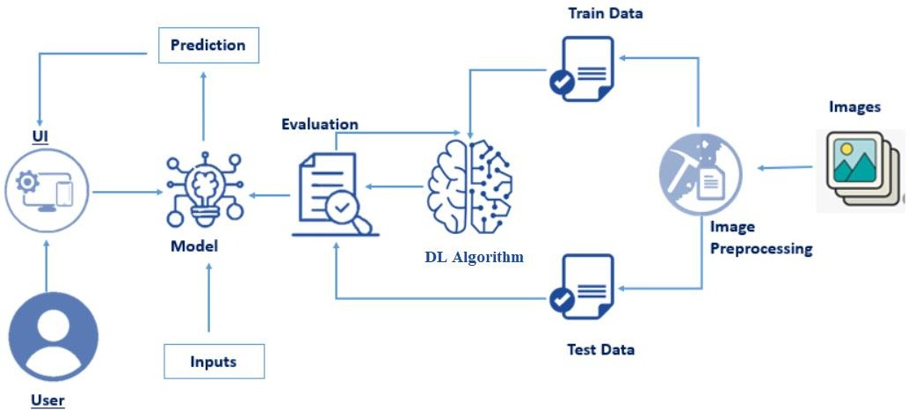

Guidelines:

Includealltheprocesses(As anapplicationlogic/TechnologyBlock)

Provideinfrastructuraldemarcation(Local/Cloud)Indicate external interfaces (third party API’s etc.)Indicate Data Storage components / servicesIndicate interface to machine learning models (ifapplicable)

Table-1: Components& Technologies:

|  |  |  |  |
| --- | --- | --- | --- |
| **S.No** | **Component** | **Description** | **Technology** |
| 1. | UserInterface | How user interacts with application e.g.WebUI,Mobile App,Chatbotetc. | HTML, CSS, JavaScript / Angular Js /ReactJsetc. |
| 2. | ApplicationLogic-1 | Logicforaprocessintheapplication | Java/Python |

|  |  |  |  |
| --- | --- | --- | --- |
| 3. | ApplicationLogic-2 | Logicforaprocessintheapplication | IBMWatsonSTTservice |
| 4. | ApplicationLogic-3 | Logicforaprocessintheapplication | IBMWatsonAssistant |
| 5. | Database | DataType, Configurationsetc. | MySQL,NoSQL,etc. |
| 6. | CloudDatabase | DatabaseServiceonCloud | IBMDB2,IBMCloudantetc. |
| 7. | FileStorage | Filestoragerequirements | IBM Block Storage or Other StorageServiceorLocalFilesystem |
| 8. | ExternalAPI-1 | PurposeofExternalAPIusedintheapplication | IBMWeatherAPI, etc. |
| 9. | ExternalAPI-2 | PurposeofExternalAPIusedintheapplication | AadharAPI,etc. |
| 10. | MachineLearningModel | PurposeofMachineLearningModel | ObjectRecognitionModel, etc. |
| 11. | Infrastructure(Server/Cloud) | Application Deployment on Local System / CloudLocalServerConfiguration:  CloudServerConfiguration: | Local,CloudFoundry,Kubernetes, etc. |
| 12. |  |  |  |
| 13. |  |  |  |
| 14. |  |  |  |
| 15. |  |  |  |
| 16. |  |  |  |
| 17. |  |  |  |
| 18. |  |  |  |
| 19. |  |  |  |
| 20. |  |  |  |

|  |  |  |  |
| --- | --- | --- | --- |
| 21. |  |  |  |
| 22. |  |  |  |
| 23. |  |  |  |

Table-2:ApplicationCharacteristics:

|  |  |  |  |
| --- | --- | --- | --- |
| **S.No** | **Characteristics** | **Description** | **Technology** |
| 1. | Open-SourceFrameworks | Listtheopen-sourceframeworksused | TechnologyofOpensourceframework |
| 2. | SecurityImplementations | Listallthesecurity/accesscontrolsimplemented,useoffirewallsetc. | e.g. SHA-256, Encryptions, IAMControls,OWASP etc. |
| 3. | ScalableArchitecture | Justifythescalabilityof architecture(3–tier,  Micro-services) | Technologyused |
| 4. | Availability | Justifytheavailabilityofapplication(e.g. useofloadbalancers,distributed serversetc.) | Technologyused |
| 5. | Performance | Designconsiderationforthe performanceofthe  application(numberofrequestspersec,useofCache, useofCDN’s)etc. | Technologyused |

References:

<https://c4model.com/>

<https://developer.ibm.com/patterns/online-order-processing-system-during-pandemic/><https://www.ibm.com/cloud/architecture>

<https://aws.amazon.com/architecture>

<https://medium.com/the-internal-startup/how-to-draw-useful-technical-architecture-diagrams-2d20c9fda90d>